FitApp

Requirements Document

Revision A

**Team members:**

Genevieve LaFrance

Jiachen Huang

Rasha Altamimi

Amal Kadi

Ian Holgate

Will Dunn

# Version Control

|  |  |  |  |
| --- | --- | --- | --- |
| **Revision** | **Editor** | **Date** | **Change** |
| A | G. LaFrance | 9/27/2015 | Document creation |
| B | W. Dunn | 9/28/2015 | Reassigned roles of resigning team member to new member Will Dunn |
| C | A. Kadi | 10/06/2015 | Adding intro, description, requirements, use cases |
| D | R. Altamimi | 10/07/2015 | Sitemap, security requirements |
| E | 1. Kadi | 10/15/15 | Added checklist under ‘progress’ section |

Contents

Version Control 1

Introduction 3

Purpose 3

Scope 3

General Description 3

System Environment 3

System Function 3

User types 3

Use cases 3

Primary Requirements Stakeholders 4

Requirements 4

Interface Requirements 4

Sitemap 5

Functional Requirements 6

FR1. Signup 6

FR2. Login 6

FR3. Input personal data 7

FR4. Retrieve analysis 7

FR5. Read general information 7

Non-functional Requirements 8

Product requirements 8

Organizational requirements 8

External requirements 9

Progress 10

Mockup/Wireframes 11

# Introduction

## Purpose

This project is a part of CS673 (Software Engineering). The main functionality of the software is to track a person’s health and everything related to food consumption, fitness, and wellness.

## Scope

The scope is not very clear yet, for now, the project will be web based and with manual user input. Future updates could include a mobile app and sync with different fitness devices such as FitBit and Jawbone Up and others.

# General Description

## System Environment

FitApp system will consist of a web portal where users (actors) have their own accounts to input their data in and retrieve statistics and graphs to analyze their input. The web portal will communicate with the database to store and retrieve users’ data.

## System Function

Users of FitApp will be able to input data such as amount of calories consumed, number of hours slept, number of steps taken. The system will in return provide the users with analysis of their input and based on that will provide some tips on how to improve the wellness of the users.

### User types

The system has 1 type of users only; FitApp users. However, some users can access general data without the need to have a personal account (read nutrition and wellness articles and tips, view general statistics)

### Use cases

User

# Primary Requirements Stakeholders

|  |  |
| --- | --- |
| **Name** | **Role(s)** |
| Rasha Altamimi | **Design & Usability Leader, Requirements Leader**, Utility Developer |
| Genevieve LaFrance | **Project Manager**, Document Control, Utility Developer |
| Jiachen Huang | **Lead front-end developer**, Data Analytics Leader, Utility Developer |
| Amal Kadi | Backup Project Manager, Meeting Minutes (& Communication) Coordinator, **QA Leader**, Utility Developer |
| Ian Holgate | **Lead back-end developer**, Utility Developer |
| Will Dunn | **Technical Writer**, Security Advisor, Utility Developer |
| Professor Czik | **Customer Representative** |

# Requirements

## Interface Requirements

A first time user to the FitApp web page will get the home page where they can either register for an account or access articles and tips on wellness. The web site will also contain general anonymous analysis of the current users of FitApp which will be of benefit for future wellness hardware development, and will allow single-focus companies (like a pedometer manufacturer) access to total-body data points to increase the effectiveness of prediction algorithms and device interaction with the device wearer.

The site will be easy to navigate. (Acceptance Criteria: Sitemap is only 3 layers deep).

### Sitemap

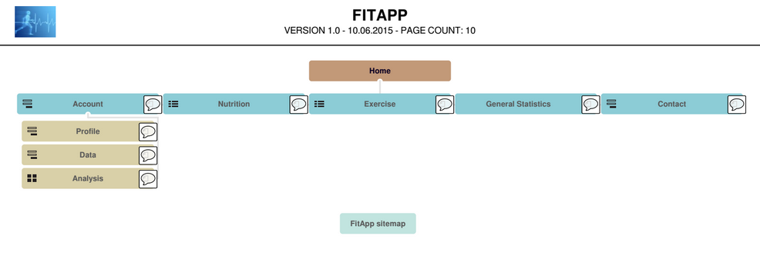

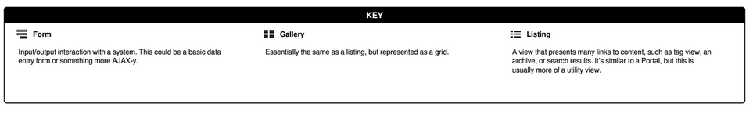

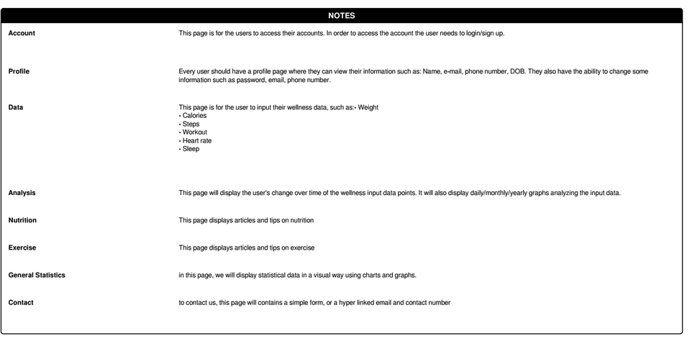

## Functional Requirements

### FR1. Signup

User

#### Use case

#### User requirements

FitApp should allow new users to sign up or register

#### System requirements

1. A first time user of FitApp website will be directed to a page to register.
2. The user will get a form to fill with basic information such as (Name, email, password, Date of Birth).
3. The form will be submitted to the FitApp database and the user’s new profile will be created.

### FR2. Login

#### Use case

User

#### User requirements

FitApp should allow registered users to login to their accounts and reset their passwords if forgotten

#### System requirements

1. Current users can click on the Account link to log in to their accounts
2. They will be given a form to input their email and password.
3. Upon successful verification of the email and password from the FitApp database the user will be granted access to their account.
4. If the user forgot their password they have the choice to click on “forgot your password?” link and be sent a password reset email.

### FR3. Input personal data

#### Use case

User

#### User requirements

FitApp should allow registered users to input wellness personal data to their accounts

#### System requirements

1. Users who have already logged in to their accounts can go the Input personal data page.
2. The users will be given a form to input information such as: Number of steps, hours of sleep, heart rate, calories consumed, workout, etc. They will also be able to specify the times of these input data points.
3. The users input is optional, if they don’t wish to input all information no error will be generated.
4. All input will be sent to FitApp database and stored there with timestamps to track changes.

### FR4. Retrieve analysis

#### Use case

User

#### User requirements

FitApp should allow registered users to retrieve analysis and graphs of their input wellness personal data

#### System requirements

1. Users who have already logged in to their accounts can go the Analysis page.
2. The analysis page will display a group of graphs analyzing the user’s input change over time.
3. The user can specify the analysis to be a weekly view/monthly view/yearly view. The can choose the specific week or month to view the change during that time.
4. The page will also display tips for the user to improve their wellness.

### FR5. Read general information

#### Use case

User

#### User requirements

FitApp should allow all users (registered and non-registered) to view general information and articles of nutrition and exercise in addition to anonymous general analysis of all FitApp users

#### System requirements

1. All FitApp users can access the General statistics page showing analysis and statistics on FitApp users.
   1. The page will provide analysis on the average input data points of FitApp users and their change overtime.
   2. The analysis will be anonymous so it will not affect the privacy of FitApp users.
2. All FitApp users can access the nutrition page displaying articles and tips on nutrition.
3. All FitApp users can access the exercise page displaying articles and tips on exercise.

## Non-functional Requirements

### Product requirements

#### NR1. Availability

1. This site’s downtime during any day shall not exceed 1 minute.

#### NR2. Usability

1. The site will be complete, and each hyperlink and button will lead to a tested event.
2. The site must allow for blank input, to support the case where the user chooses not to share a category of fitness/wellness data.
3. The site will adhere to the “3 click” rule, where each the sitemap is 3 or fewer layers

### Organizational requirements

#### NR3. Financial

1. The site will have a budget of $0.

#### NR4. Schedule

1. The site will be complete by December 7, 2015
2. The site will undergo a phase 1 review, and will display a completed skeleton on October 19, 2015.
3. The site will undergo a phase 2 review, with input and trend analysis complete on November 16, 2015.

|  |  |  |
| --- | --- | --- |
| **Week** | **Due Date** | **Action Items** |
|  | 10/5/2015 | Finish PM Setup tasks (schedule, proposal, risk) |
|  | 10/13/2015 | - Incorporate customer suggestion into proposal/schedule  - Requirements analysis complete  - Tools and technology training complete  - back-end toolbox started  - project started in GIT |
|  | 10/19/2015 | Phase 1 demo (show wireframes and site structure)  - site header/footer complete  - each page started  - site color/design decided  - login complete |
|  | 10/26/2015 | Implement login |
|  | 11/2/2015 | Implement structure for input and tracking of step counter |
|  | 11/9/2015 | Implement other metrics (Calories, heart rate...) |
|  | 11/16/2015 | Phase 2 demo  - slack week – plan for debugging and QA |
|  | 11/23/2015 | - Incorporate customer suggestions into schedule/site |
|  | 11/30/2015 | QA week complete  Debugging complete  Presentation preparation |
|  | 12/7/2015 | Project Complete  Final Demonstration |

### External requirements

#### NR5. Security

The system should be secure against malicious users. It will be secure again SQL injections, XSS and CSRF attacks.

1. The site will keep user data secure by requiring a username and password
   1. The website will enforce users to use strong complex password such as a minimum of eight characters, including at least one uppercase letter and one number which will help to protect their information against brute force password guessing.
   2. The passwords will not be stored in FitApp databases in the clear, instead, a hash of the password will be stored along with a salt to prevent any leakage of information and secure the password of the users.
2. The site will be secure against SQL injections
   1. We can easily prevent this by using sanitized queries when we create the database for the website.
   2. We will use messages like “Incorrect username or password” without any details about the query to prevent an attacker from trying brute force attack to get information from error message gives away when one of the fields are correct then the attacker knows he has one of the fields and can find the way to attack the database .
3. XSS
   1. Cross site scripting is when an attacker tries to pass in scripting code into a web form and we can prevent it by sanitize any user input before it is processed.

## Progress

|  |  |  |  |  |
| --- | --- | --- | --- | --- |
| Requirement | Status | Start date | Completion date | Notes |
| FR1. Signup |  |  |  |  |
| FR2. Login |  |  |  |  |
| FR3. Input personal data |  |  |  |  |
| FR4. Retrieve analysis |  |  |  |  |
| FR5. Read general information |  |  |  |  |
| NR1. Availability |  |  |  |  |
| NR2. Usability |  |  |  |  |
| NR3. Financial |  |  |  |  |
| NR4. Schedule |  |  |  |  |
| NR5. Security |  |  |  |  |

# Mockup/Wireframes

Mockup Location: <https://gomockingbird.com/projects/5du4ei8>

